Republic of Palau – Financial Intelligence Unit

Executive Summary

Student Consultant, Apoorva Havanur

Community Partner, Nelson J. Werner & Hussein “Boboy” Derbai

# I. About the Organization

## Organization

The Financial Intelligence Unit (FIU) of the Republic of Palau is an autonomous organization

which reports to the Governing Board of Commissioners of Financial Institutions

Commission (FIC). FIC is responsible for the oversight, supervision and regulation of the Republic

of Palau’s financial sector and the Governing Board members are appointed by the President of the

Republic of Palau.

The mission statement of the FIU is,

*To detect, disrupt and deter money laundering and terrorist financing. To*

*ensure that Palau anti money laundering regime complies with international*

*standards. To that end, the financial intelligence unit collects, analyzes and*

*stores financial data and intelligence for possible money laundering and*

*terrorists financing prosecution.*

The vision statement of the FIU is,

*For Palau to be free of money laundering and terrorist financing.*

The Financial Intelligence Unit strives to achieve its mission by receiving and analyzing

information from various sources to identify possible activities related to money laundering or

terrorist financing. The current sources of information are the three retail banks in the country, i.e.

Bank of Hawaii, Bank of Guam, and Bank Pacific, and the Bureau of Customs and Border

Protection. All the three banks share their information with FIU by generating Currency Transaction

Reports (CTR) and Suspicious Activity Report (SAR) or Suspicious Transaction Report (STR).

A Currency Transaction Report (CTR) is a report that financial institutions are required to file to the

FIU for each deposit, withdrawal, exchange of currency, or other payment or transfer, by, through,

or to the financial institution which involves a transaction in currency of more than $10,000.

A Suspicious Activity Report (SAR) or Suspicious Transaction Report (STR) is a report made by a

financial institution about the suspicious or potentially suspicious activity. The report must be made

when any financial transaction that does not make sense to the financial institution, is unusual for

that client or appears to be done only for hiding or obfuscating a transaction.

The FIU, along with TCinGC program of Carnegie Mellon University, has successfully developed a

sophisticated database for the electronic acquisition of financial data. In addition, for effective

dissemination and investigation of money laundering, the FIU has created a Financial Crimes

Investigations Unit (FCIU) with other relevant law enforcement agencies such as the Bureau of

Customs and Border Police, the Office of Attorney General, the Office of Special Prosecutor, the Bureau of Revenue and Taxation Criminal Investigation Division, the Postal Inspector and the

Bureau of Public Safety. The FIU identifies and analyzes suspicious or illegal activity and passes its

amassed intelligence to the FCIU for further investigation.

## Facilities

The Financial Intelligence Unit is located in an office on the second floor of the IA Meda Korner Building in Koror, Palau. It shares the second-floor facilities with the Financial Institutions Commission (FIC). To this end, the Financial Intelligence Unit and the Financial Institutions Commission work together to monitor financial activity in Palau. In terms of physical space and organization, the size, furnishings, and layout are adequate for the current operations of the Financial Intelligence Unit. There are three desks in the office, which are used by Nelson and Boboy for day-to-day work, as well as a larger conference table used for meetings. At two of the desks is a desktop computer; there are an additional three laptops in the office. The access to power at the Financial Intelligence Unit office is also satisfactory for its needs: there are sufficient power outlets in the office to power all of the electronic devices (i.e. – computers, phones, etc.) the Financial Intelligence Unit has, as well as those of guests, and sufficient power to provide climate control and lighting for the office. The security to the office is also ample, being that the door to the Financial Intelligence Unit office is locked at night, as is the door to the second floor that contains the Financial Intelligence Unit and Financial Institutions Commission offices.

## Intelligence Gathering

## The FIU receives information from the local retail banks and the Bureau of Customs and Border Protection and stores it for intelligence gathering. During analysis, this information is utilized to find any evidence trail of money laundering. Before 2015, the information was paper-driven. Searching and analyzing information was next to impossible. Therefore, the whole process was digitized during 2015. Currently, the FIU has a digital database in place and all the three retail banks send the CTRs and STRs in csv format. Hussein ‘Boboy’ Derbai, Senior Intelligence Analyst at the FIU, needs to retrieve the data from the bank-specific portal within a limited timeframe. Moreover, the CTRs and STRs transmitted by the bank have minor errors. Therefore, he goes through the data manually to check for such errors before importing it into the database. There are currently over 18,000 CTRs and 300 – 400 STRs currently in the database.

## Staff

Currently, there are two full-time employees in the Financial Intelligence Unit, Republic of Palau. Mr. Nelson Jay Werner is the Director of the FIU, Republic of Palau. He is responsible for the overall supervision of the FIU, which includes staff, contracts and public affairs. He is also responsible for implementing Anti-Money Laundering(AML) policies in the Republic of Palau i.e. develop, disseminate and verify compliance with policies to prevent money-laundering and terrorist financing. He also represents the FIU at international forums and conferences. Nelson uses computers for general office work, such as email, word processing, and research. His laptop is preloaded with Microsoft Office applications (i.e. – Microsoft Word, Excel, Access, etc.) and uses Microsoft Outlook for accessing email. A lawyer by profession, his primary resource for technology training is the Internet, and while familiar with Office tools like Word and Excel, does not have extensive knowledge of how to use databases. Mr. Hussein ‘Boboy’ Derbai is the Senior Intelligence Analyst of the FIU, Republic of Palau. His role is to support the Director in the process of implementing the AML policies. He recommends the dissemination of suspicious transaction reports (STRs) to the director and supervise the process of exchanging information with foreign FIUs. His access to and use of technology is largely like Nelson’s, except that he has more proficiency in using the Financial Intelligence Unit’s current Microsoft Access database. As such, he is primiarly responsible for cleaning and uploading the data on CTRs and STRs that is uploaded into the FIU's database. Boboy’s access to technology training is like Nelson’s.

## Technology Infrastructure

## The Financial Intelligence Unit has five computers, whose processor specs vary from Core i3 Quad-core to AMD TurionX2 Dual-Core Mobile. Except selected laptops having 2GB RAM, all the other laptops have 4GB RAM. All computers have Microsoft Office 2007 Package Suite pre-installed. Moreover, all the systems have access to the Internet via Wi-Fi (with the necessary web browser).

## In terms of non-computing technology, the Financial Intelligence Unit’s office is equipped with phones (“landlines”) and a scanner/printer that is accessible over the local network.

## Recently, an undersea cable was established that provides a much higher quality Internet connection on the islands. The FIU's internet bandwidth goes up to 2.0 mbps for upload and download. This is a significant upgrade over previous Internet speeds, and allows the FIU to communicate more efficiently, as well as transfer large files between themselves at a faster rate.

## Technology Management

## Since the staff at the Financial Intelligence Unit involve only 2 members, the current technology management plan is ad-hoc. In addition, the technology infrastructure involves just 2 user systems, one network device and one printer. Therefore, technology management at the Financial Intelligence Unit is done on a largely ‘as needed’ basis. Since Boboy is more adept to the computer hardware technology, he is responsible for solving any system issues. Boboy’s current technical expertise, as it relates to technology management, largely consists of the ability to use computers, meaning he can perform tasks such as installing software or updating virus definitions through a graphical user interface. Beyond these tasks, the Financial Intelligence Unit relies on external limited services to manage its technology infrastructure. Furthermore, they currently do not have the budget to permanently hire an external vendor like Conrad, who is a dedicated information technician for government organizations in Palau. Given this lack of external support and internal capacity, the technology management portion of the Financial Intelligence Unit’s organizational practices is limited. All the systems have Avast Antivirus installed.

## Technology Planning

## Technology planning at the Financial Intelligence Unit is largely done by Boboy. However, the final decision of purchase is done by Nelson. There is no specific budget allocated for IT management. However, 5.7% of the overall budget is allocated for buying office equipment. Computer equipment is bought utilizing this budget. Regarding technology planning and best practices, Nelson and Boboy gain information about comparable international practices by attending conferences on money-laundering and terrorist financing prevention and dually observing the best practices showcased there. They also communicate with the other Financial Intelligence Units in attendance about their technology infrastructure.

## The current technology plan, to first establish and then incrementally enhance the database, has been in place since Nelson created a technology plan for the Financial Intelligence Unit.

## Communication

## Internally, information at the Financial Intelligence Unit is shared verbally, using a flash drive, or through email. With external organizations, it is shared via email or phone conversation. As such, the Financial Intelligence Unit does have the capacity to share files, both internally and externally. Regarding the security of the files shared via email, the email accounts at the Financial Intelligence Unit are password-protected and have the capacity to be encrypted. Previously, bandwidth in Palau did not allow upload or download speeds above 256 kbps, which causes issues for the Financial Intelligence Unit when its employees need to communicate or share large files via the Internet. Currently, however, the bandwidth has increased, allowing the FIU to easily transfer large files both internally and externally. For its purposes, the one to one communication capacity of the Financial Intelligence Unit is appropriate for its needs.

## Information Management

## The main role of Financial Intelligence Unit is to store all the information regarding suspected money-laundering activities and analyze them. Therefore, it handles its information management needs using a Microsoft Access database. The database application was created by two consultants participating in the Technology Consulting in the Global Community (TCinGC) program during 2015. It was further enhanced by other consultants who participated in TCinGC program during 2016 and 2017. The organizations that submit these reports to the Financial Intelligence Unit have transitioned to electronic submission now.

The FIU updates its database every Friday, and keeps three backups of the data, each on an external hard drive – one is left in the FIU office, one is left with the FIC, and another is kept in the possession of Boboy, who takes it home with him.

## Business Systems

FIU reports to the Governing Board of Financial Institutions Commission (FIC). Therefore, the

accounting and HR processes are taken care by the FIC.

# II. Simplifying Data Entry in the FIU Database (FIND)

## Motivation

Each week as new CTRs and PITs are generated by the financial institutitons in Palau, they are collected by Boboy and entered into the FIU’s database. Up until now, the process required some minor preprocessing steps on the part of Boboy – tasks such as replacing the names “Gibsons” with “Gibbons”, adding area codes to phone numbers, etc. While the previous consultant left detailed instructions on how to do these tasks within Excel, an application Boboy knew well, there were two major issues with the current system:

The first was that working in Excel produced some unexpected problems: When a string like "330000,3450000,3600000" is opened in Excel, it attempts to parse the string as one contiguous number (with weirdly placed commas). To avoid overflow, it will leave out the least significant digits, leading it to look like the number "33,000,000,000+" on Excel. The previous consultant had seen this issue, and suggested just taking the first part of the number to use as the account number. Because of this, many past records had incomplete or incorrect bank accounts provided.

The second problem was efficiency and correctness. It would take Boboy significant time to identify and fix these issues, and despite his training, it is possible for him to miss certain issues, especially subtle ones.

Thus, for the issues listed above, it was decided that automating the preprocessing would greatly benefit the FIU.

## Outcomes

To solve this problem, we first identified key aspects of the task – the first was that the preprocessing were fairly consistent. Working with Boboy, we identified a list of preprocessing steps that he normally applied to any CTR or PIT record he was given:

* Removing extraneous characters from listed cash amounts (i.e “$34,000” -> 34000)
* Changing initialisms of countries to their full name (“GU” -> “Guam”)
* Correcting instances of particular names (misspellings, last names in place of first names, etc)
* Padding CTRIDs with 0s until they are 9 digits long
* Padding phone numbers with missing area codes with the Palau area code

Another aspect of the task is that the process for entering the data into the FIU database was already designed to handle taking in PIT and CTR records as they came from the financial institutions. So any preprocessing must leave the data in the same structure that it already was in.

Finally, the preprocessing step happens arbitrarily. While banks generate CTRs and PITs weekly, there is usually some delay in getting these records to the FIU, and then an additional delay in entering them into the database. So, any automated program to run the preprocessing must be able to run as needed, and provide a simple interface that Boboy or another member of the FIU can easily run on their own.

With these considerations in mind, I generated two applications, one to process PIT records and another for CTRs. Each application is a simple .exe file, which, when run, displays a simple UI to select a .csv file, and outputs a new .csv file that has all the necessary changes made. This new .csv file is what enters into the FIU database.

Throughout the 10 weeks, these processing applications went through several revisions after encountering new edge cases week after week. Ultimately, the current versions of both applications has been used successfully by Boboy to automate the data processing aspect of his work, saving him needless hours of work each time he needs to enter in new PIT and CTR records.

## Recommendations

While the current versions of these applications are well suited to the task, they are prone to errors whenever new edge cases or formatting styles are used by the banks. Therefore, future versions of this application could incorporate the ability to manually adjust the preprocessing steps, potentially utilizing something like Office’s “Record Macro” setting.

# III. Integration with External Data Sources

## Motivation

Over the past year the FIU has been able to effectively use the database built by former TCinGC student consultants to store and efficiently access data critical to their investigations, like CTRs and STRs. However, in the course of building up a case, the FIU often pulls information from other agencies related to the individual that they are investigating, such as:

* Tax records
* Cross border currency reports (CBCRs) from Customs, acknowledging the movement of large amounts of currency (over $10000) between countries.
* Bank records

Currently, when the FIU is investigating a case, it must manually call up these other agencies and request the relevant information, which often comes in the form of paper documents, or, in the case of Customs, read-only access to the Customs database. This is time-consuming for the FIU, where then they have to keep track of specific bits of information and constantly try to refer back to it, rather than have it all available to them at once.

We wanted to improve how easily the FIU can integrate with these external data sources, allowing them more information that they can use as part of their case.

## Outcomes

Thanks to several inter-agency meetings, we were able to secure the cooperation of Customs and Immigration in readily sharing information with the FIU. Both agencies utilize a third party database software that provides Boboy with ‘view only’ access to their databases. Through our meetings, we were able to receive the additional functionality of downloading information from their database in the form of specially formatted reports (see appendix).

Now with the information in a somewhat structured format, I developed two additional .exe scripts that can parse the report format that these records are given as and put them into a tabular format. I also extended the functionality of the FIU database so that Customs and Immigration records can be imported into the database, assigned to a particular case using a Case ID, and, once imported into the database, can be manually searched, edited, or added, the same way that CTRs and STRs can be. Now, the FIU can match an individual to their travels in and out of Palau and their currency declarations at the time of their transit.

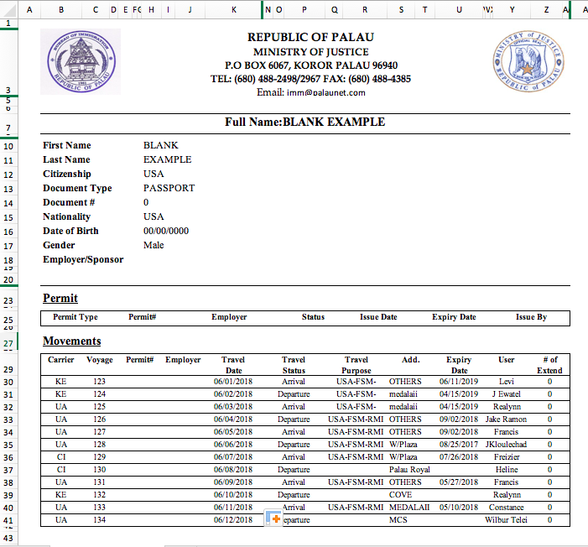

Sample Immigration Form

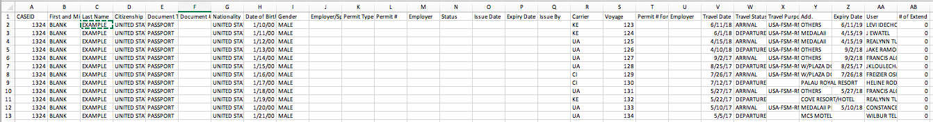

Sample Output After Processing

## Recommendations

There are still several other data sources that can be incorporated into the FIU’s database that are relevant to its anti-money laundering mission. The Attorney General’s office is transitioning into using the same database system as Customs and Immigration – once finalized, this information can also be incorporated into the FIU’s database, which further improves the quality and quantity of intelligence work the FIU can do.

# IV. Structured Analysis of Cases

## Motivation

As the FIU becomes more sophisticated in the management of data related to money-laundering in Palau, their next task is to figure out how to automatically generate analysis that are part of their investigations. This serves a dual purpose – not only does it speed up a time consuming process for the FIU, but it also helps them comply with regulatory agencies that manage FIUs around the region.

## Outcomes

After interviewing Nelson and Boboy about their data needs, as well as ascertaining the current capabilities of the FIU, one glaring issue was the lack of data visualization tools at their disposal. Data visualization helps the FIU by making it easier to see trends in behavior over time, as well as spot abnormalities and make connections between different events. Moreover, the Palau FIU is continuously asked to generate reports and present at international conferences, where the ability to convey relevant information easily is a useful asset. As a result, the priority of this recommendation became to develop various methods for the FIU to visualize the data they had available.

The result was an analytics and visualization dashboard, the Report Analytics & Intelligence Data Examination in R (RAIDER). RAIDER integrates with the FIU database to provide several different forms of data visualization that can be adjusted for more granular views. The RAIDER is broken into different tabs, each covering a different area:

* CTR Summary: This visualization displays a graph of CTR filings over time, separating deposits and withdrawals. There are several possible user inputs that filters the data and changes the visualization that is displayed
  + **Banks** – which of the three Palau financial institutions that provide CTRs should be included
  + **Cash Flow** – whether deposits, withdrawals, or both should be shown
  + **Date Range**
  + **Cash Range –** for each filing
  + **Number of Accounts**
  + **Display Banks Individually** – default is to aggregate sums of each bank
  + **Display Net Cash Flow –** Display a trend line across the time series that takes the net total by subtracting withdrawal amounts from deposits
  + **First and Last Name of Individuals** – selecting multiple individuals aggregates all their accounts
  + **Occupations –** Using fuzzy string matching, select all CTRs where the person has listed their occupation that match the input.

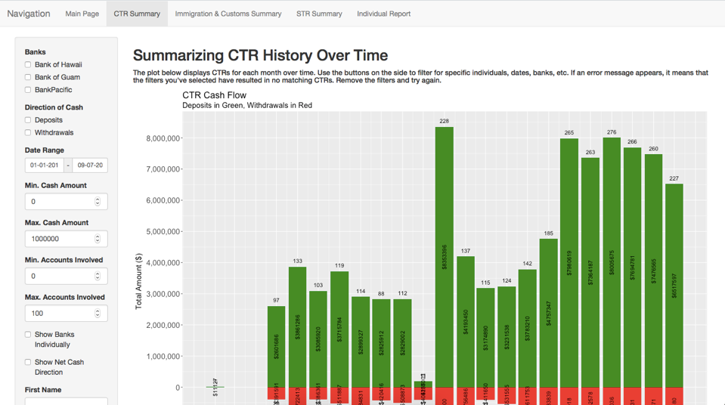

* Immigration and Customs Summary: This visualization is a global map that shows the movement patterns identified in the immigration and customs data collected, along with a graph showing the flow of currency (calculated in USD) in and out of Palau. Here, the user inputs are
  + **Date Range**
  + **Cities Traveled To** – Palau has limited service to only a small number of locations that can be individually tracked
  + **First and Last Name of Individuals** – selecting multiple individuals aggregates all their travels and declarations
  + **Airlines Travelled On**
  + **Case ID**
  + **Cash Range –** for each customs declaration

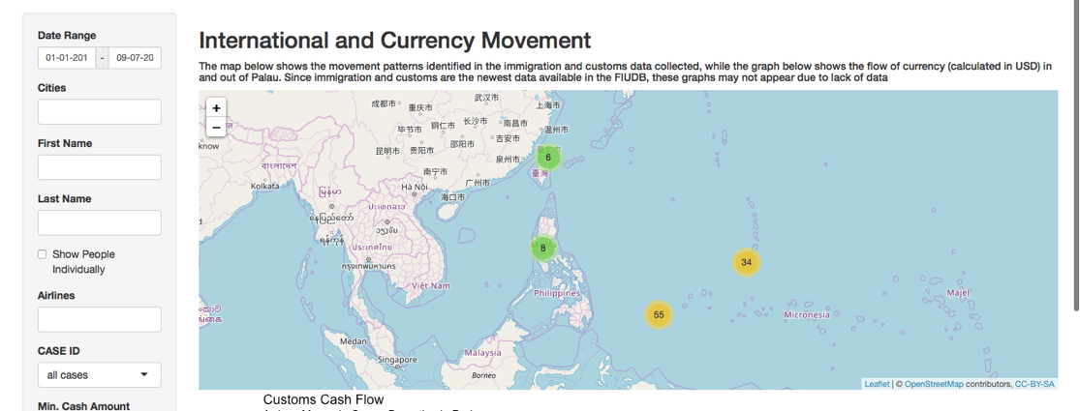

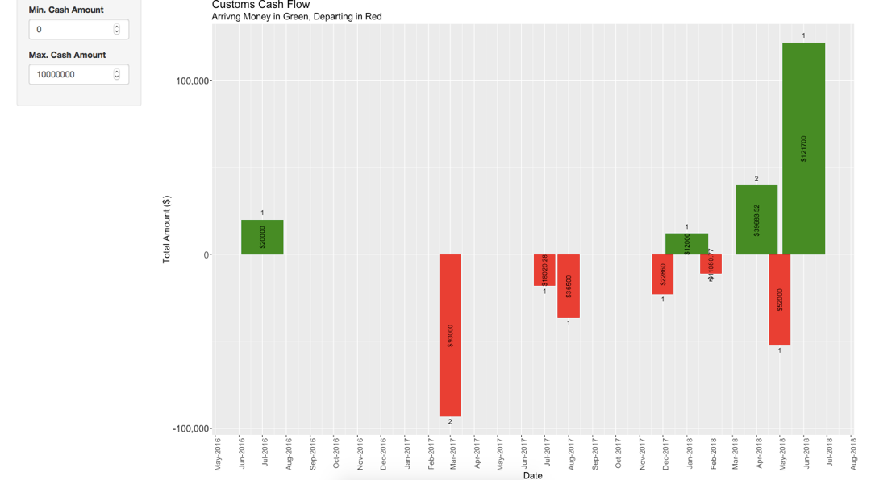

* STR Summary: The visualizations on this tab displays STRs for each month over time, as well as a word cloud below identifies keywords in the narratives of the displayed STRs. Here, the user inputs are:
  + **Banks** – which of the three Palau financial institutions that provide STRs should be included
  + **STR Generation Date Range**
  + **STR Suspicious Transaction Date Range –** the difference between these two date ranges is when the transaction occurred (possibly over the course of several days) and when it was officially recorded (sometime after)
  + **Cash Range –** for each filing
  + **Number of Accounts**
  + **Display Banks Individually** – default is to aggregate sums of each bank
  + **First and Last Name of Individuals** – selecting multiple individuals aggregates all their accounts
  + **Occupations –** Using fuzzy string matching, select all STRs where the person has listed their occupation that match the input.
  + **Characterization –** Using fuzzy string matching, select all STRs where the suspicious transaction has a known characterization (i.e “fraud”)
  + **Narrative -** Using fuzzy string matching, select all STRs where the attached narrative contains a known keyword or phrase (such as “ATM”, “money laundering”, etc.)
  + **Admission –** whether or not an admission of guilt was registered (very few transactions include one)

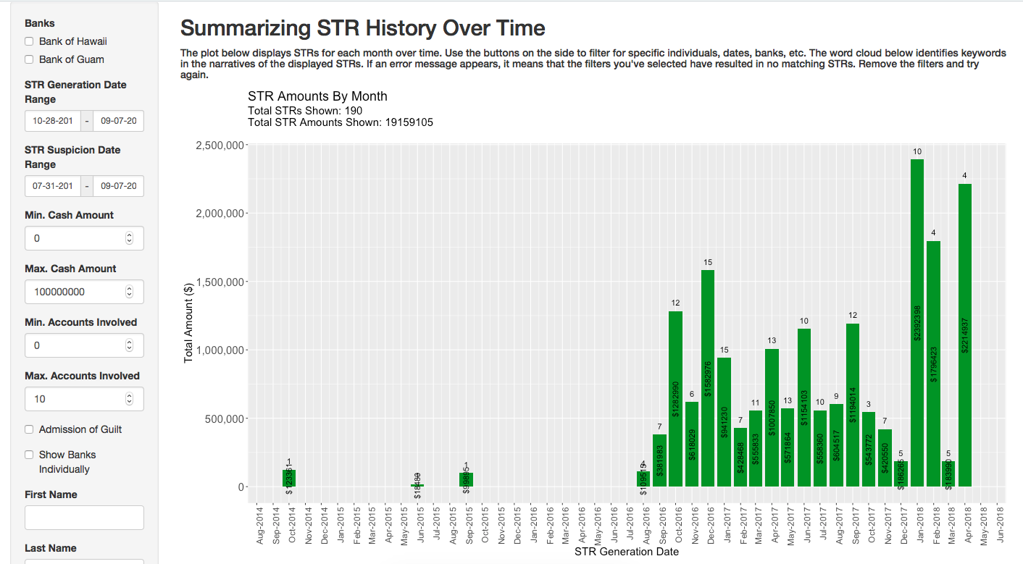

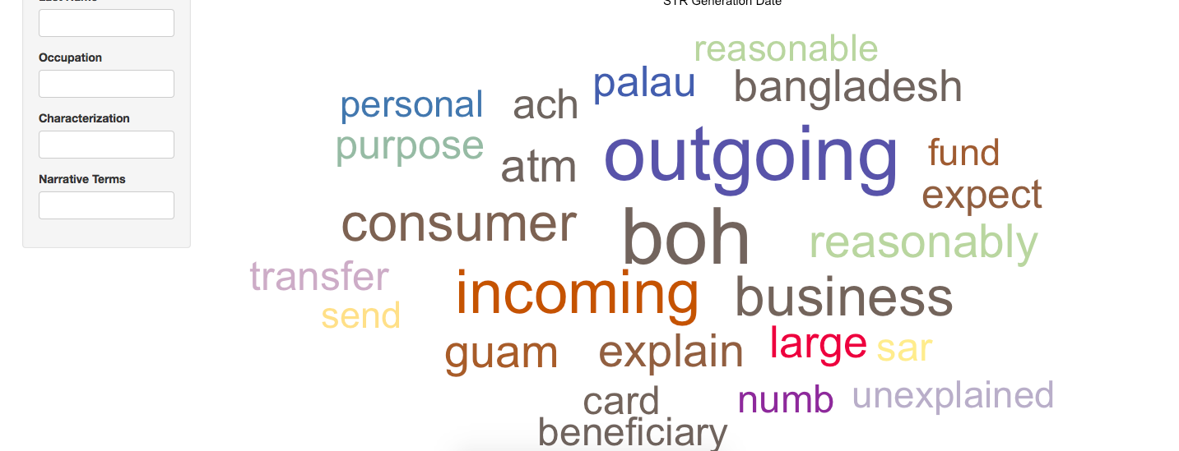

* Individual Report: This tab displays all the above visualizations for one specific individual as well as their associates. The user inputs are:
  + **Name of the Individual:** Drawn from the CTR and STR filings
  + **Include Associates:** If selected, an additional menu appears to select known associates of the individual. The associates list is populated with persons known to interact with the same accounts / be included in the same STR or CTRs as the individual.
  + **Include Accounts:** If selected, an additional menu appears to select known accounts of the individual. 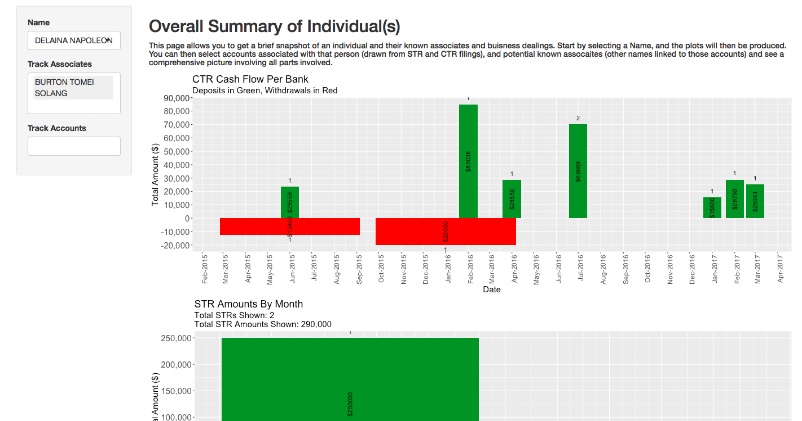

## Recommendations

While the RAIDER is a start, there is still much more than can be done for a structured analysis. One hope is that the efforts to aggregate and track individuals done within the RAIDER can be used to detect anomalies and automatically generate alerts for the FIU to follow up on. Furthermore, as more data becomes available, more sophisticated data visualization techniques can be used to combine different sources into one comprehensive narrative that can be acted upon.

About the Consultant

Apoorva Havanur is a graduate of Carnegie Mellon University majoring in Statistics and Machine Learning, with an additional major in Economics and a minor in Computer Science. He participated in the Technology Consulting in the Global Community Program this past summer, and will begin a career as a data scientist working at Facebook in the fall.

Consulting Partner

Nelson J. Werner

*director@palaufiu.org*

Formatting Freedom Foundation

44 Fording Way

*http://www.triplef.org*

About the Consultant

Apoorva Havanur

*ahavanur@cmu.edu*

Apoorva is a CMU graduate.

He will begin working as a data scientist at Facebook in the fall.

Appendix A: **Cleaning Scripts Usage**

### Technical Implementation

The cleaning scripts are written in Python, and compiled into .exe scripts using the PyInstaller module. Apart from the PyInstaller module, no external modules are needed to run any of the scripts provided. The applications, as well as the original code, can be found on Boboy’s work desktop, as well as on Github: <https://github.com/ahavanur/FIU/tree/master/CleaningScripts>. Separate branches for Windows and Mac development exist.

### CTR and PIT Cleaning Instructions

The process for running either of these scripts is same:

1. Navigate to the folder which contains the application files. Currently, they are in a “2018 Consultant” > “FIU Raider” > “Cleaning Scripts” > “Applications”.
2. Click on the application. A popup from the anti-virus software may appear. Allow it to finish its check.
3. A black terminal window will appear, followed by the system’s file directory system, asking for a file. Select the relevant .csv file (Note: file **must** be a .csv file. If the file is in .zip format, uncompress the folder before launching this script).

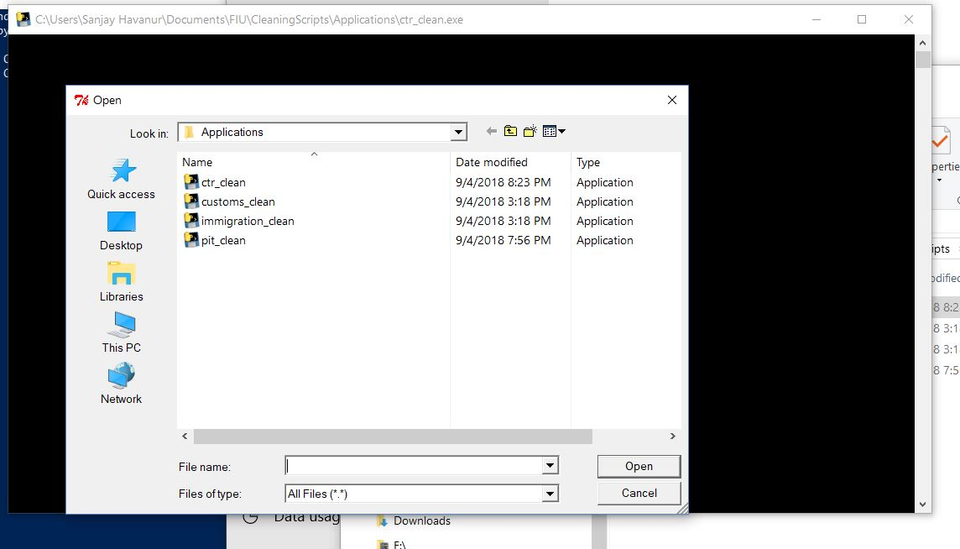

1. The black terminal window will remain open for a couple of seconds and then will close suddenly. Navigate to the folder in which the input .csv file was located. A new .csv file should appear that begins with the phrase “UPDATED_” and ends in the same name as the original file. For example, if the original file were named “CTR 1.csv”, the new file would be called “UPDATED_CTR 1.csv”.
2. Import the new file into the database as usual.

### Immigration and Customs Cleaning Instructions

The customs and immigration cleaning files differ from the CTR and PIT cleaning scripts greatly, due to the nature export format of the records. However, the usage of the applications is mostly the same:

1. Navigate to the folder which contains the application files. Currently, they are in a “2018 Consultant” > “FIU Raider” > “Cleaning Scripts” > “Applications”.
2. Click on the application. A popup from the anti-virus software may appear. Allow it to finish its check.
3. A black terminal window will appear, followed by a text box asking for a case ID. Enter the case ID and press the button. This is followed by the system’s file directory system, asking for a file. Select the relevant .xls file. 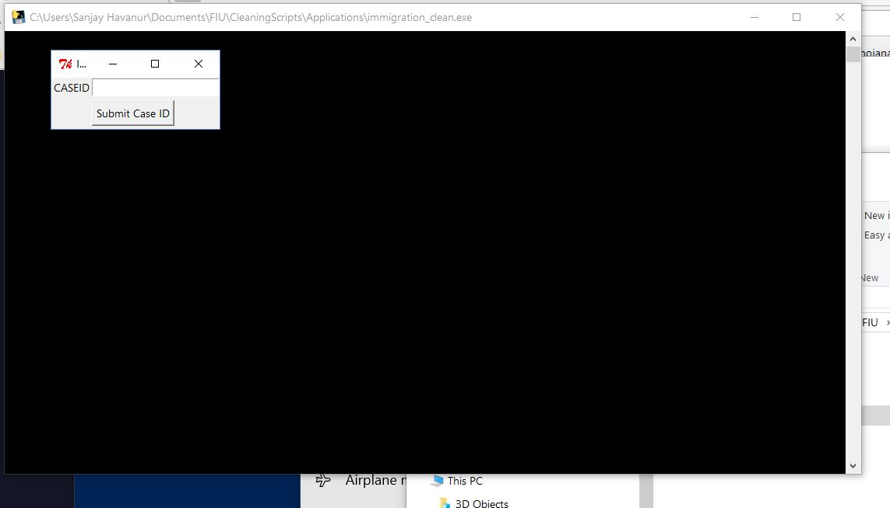
   1. If there is no case ID for the import, you can leave it blank.
4. The black terminal window will remain open for a couple of seconds and then will close suddenly. Navigate to the folder in which the input .csv file was located. A new .csv file should appear that begins with the phrase “UPDATED_” and ends in the same name as the original file. For example, if the original file were named “Immigration 1.csv”, the new file would be called “UPDATED_Immigration 1.csv”.
5. Import the new file into the database as usual.

### Updating Cleaning Scripts

From time to time, it might become necessary to update the cleaning scripts. Thankfully, it is relatively easy to make such changes without constantly having to transfer files between computers via USB, and therefore can be done remotely as well:

1. Clone the FIU Github repository onto a local machine. Be sure to track changes on the relevant operating system (currently, the FIU uses Windows)
2. Make the necessary to the code files (located in “Cleaning Scripts” > “Code”)
3. Compile the new code into an exe file using PyInstaller. Using the command line, navigate to the directory of the file and run:

python -m PyInstaller <file>.py -F

* 1. The compilation may take a few minutes
  2. When completed, the .exe file will be within a newly created ‘dist’ folder. Move this exe into the Applications folder and delete any newly created files from the Code folder
  3. **Note:** while the code can be edited from any machine, the PyInstaller compilation must occur on the same operating system as the target machine (i.e must be run from a Windows machine if trying to create an .exe file that will run on Windows). As far as I’m aware, it does not need to be the same version.

1. Commit the changes upstream to the source branch.
2. On the target computer (the FIUs), there are two ways to update
   1. **Technical:** open the command line, navigate to the directory that contains the CleaningScripts, and run

git pull origin windows

* 1. **Simple**: Open the FIU RAIDER application. Included in the run script for the FIU RAIDER is an automatic running of the above git pull command, but can be done so through the R Studio graphical interface, making it simpler for those without command line experience.

Appendix B: **RAIDER Usage**

### Technical Implementation

The FIU RAIDER is an RShiny dashboard. RShiny is an R framework that’s similar to React and Javacript in terms of style. Simple tutorials are available online for its usage, as well as for base R itself. The full application, excluding the data is available on Github: <https://github.com/ahavanur/FIU/tree/master/FIUDBAnalysis>.

### RAIDER Launch Instructions

1. Open up the FIU Database. On the main menu, click on Export
   1. Note: be sure to provide permission if asked for by the anti-virus software.
2. Navigate to the directory “FIUDBAnalysis”. Currently, it is located in “2018 Consultant” > “FIU Raider” > “FIUDBAnalysis”.

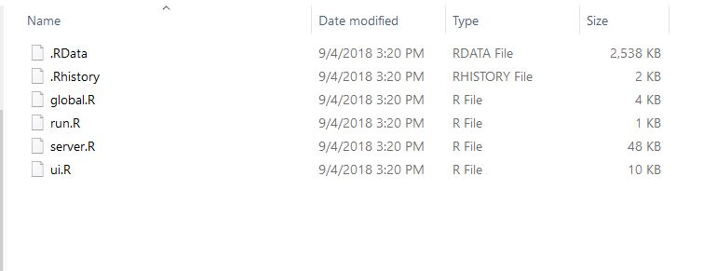

1. Open the file “run.R”. The default behavior should be to open it in a program called “R Studio”. If not, right-click on the file, select “open with” and click on “R Studio”.

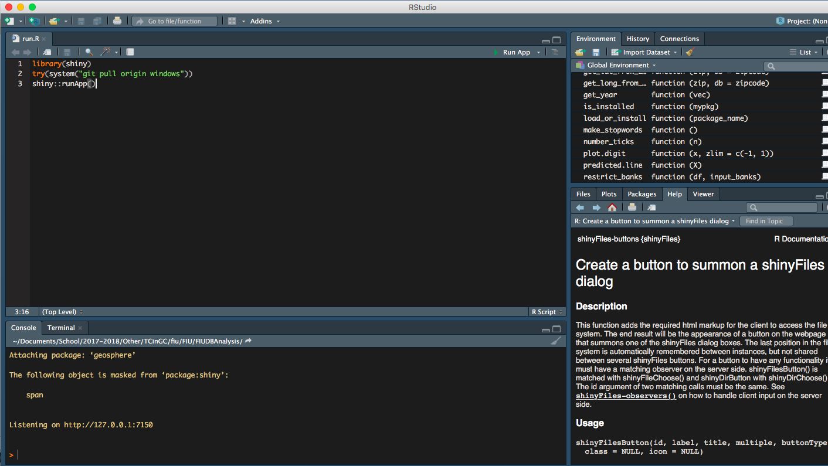

1. Once the file is open, there is a button on the top right that says “Run App”. Click on “Run App”.
2. The program will output some text near the bottom of the screen for a few seconds, and then open up the first page of the FIU RAIDER.
3. Click on the “Choose Folder” button

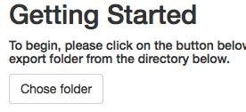

1. Navigate to the folder that contains the FIU Database. There should be a new folder called “FIU Export”. Select that folder.

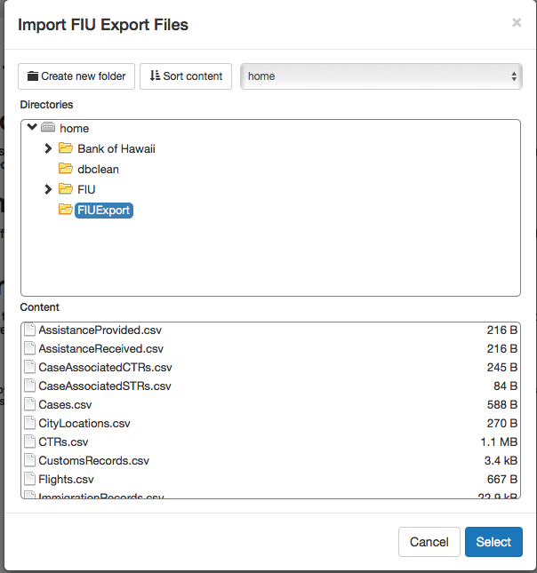

1. Once the folder has been selected, you can now select any of the tabs, and follow the instructions on each tab for their usage.

### Updating RAIDER

Much like the Cleaning Scripts, the RAIDER can also be updated via Github, but nothing needs to compile separately.

1. Clone the FIU Github repository onto a local machine. Be sure to track changes on the relevant operating system (currently, the FIU uses Windows)
2. Make the necessary to the code files (located in “FIUDBAnalysis”)
3. Commit the changes upstream to the source branch.
4. On the target computer (the FIUs), there are two ways to update
   1. **Technical:** open the command line, navigate to the directory that contains the FIUDBAnalysis, and run

git pull origin windows

* 1. **Simple**: Open the FIU RAIDER run.R file. Included in the run script for the FIU RAIDER is an automatic running of the above git pull command, but can be done so through the R Studio graphical interface, making it simpler for those without command line experience.